

**Madini Africa**

**Madini TraceChain  
EA BlockChain Supply Chain Traceability**

Bluegate Business Solutions LTD (Kenya) 2001 – www.bluegatebs.com

[www.madinitracechain.com](http://www.madinitracechain.com/)

One-stop app that connects producers with consumers and captures all value chain data from end to end. Empowering producers and building D2C models with blockchain.

Connect producers with consumers and capture all value chain data E2E

Enable African Enterprises to introduce and complete *Proof of Concepts* on Blockchain Efficiently.

Madini TraceChain is a platform that engages producers with consumers and enables them to gather and share data with the public via a QR code. All the information is encrypted and secured on VeChain blockchain, and is unforgeable and available worldwide.

##### **VeChain powered**

At Madini, we believe **VeChain Thor Blockchain** has the potential to powerfully disrupt many aspects of how businesses and economies work, even how societies are organised. Blockchain goes to the core of the role of trust in **African Products** – an area that is central to Madini purpose. This shapes the way we think through the challenges Africa faces – bringing together business acumen, user experience design, and existing and emerging technology.

We deliver blockchain solutions that reflect African specific business needs, and provide trust, transparency, and security. Together, we can differentiate your business and help you set the stage for future growth.

##### Fast and safe trade

As a pioneer in transparent trade value chains, Madini TraceChain aims to empower African producers by establishing a direct market linkage facilitation to incentivize regeneration, from soil to economy to society at large with a powerful transparency application.

Powered by Bluegate, the TraceChain application collects and uploads authentic product information onto the VeChainThor Blockchain, This enables a traceable, visible, and transparent digital marketplace for the African market, which allows for producers, processors, packers, distributors, brands and other added-value stakeholders to publicly list Organization and Product profiles to access global markets.

##### A force for the good

Many projects leverage blockchain to increase supply chain transparency and detect operational inefficiencies as well as new business opportunities. However, few of them are as impact driven as TraceChain. In addition to private corporations, Bluegate works with governmental organisations and NGOs to have a positive social impact and empower underserved producers.

At Bluegate, we believe VeChain has the potential to powerfully disrupt many aspects of how African Markets work, and provide trust, transparency, and security to the supply chain. This includes artisans and small-scale farmers being part of our inclusive value chain that underpin human health, well being, livelihoods, jobs and sustainable growth.

Madini TraceChain system is about sustainability, quality, authenticity, fairness, ecological footprint,origin and provenance, safety and traceability. Then the company must gather evidence from their supply chain of the performance for the characteristics chosen, proof of actions by people and machines, documents such as certificates, licenses or chemical analysis and collecting or importing data from production systems (ERPs).

Madini TraceChain, a blockchain-enabled trade solution can help African companies exploit value via data generated by their own business. The immutable data on the blockchain enables companies to increase the efficiency of compliance review, government supervision, logistics and supplier evaluation and more. Companies will also gain access to world leading third-party services through Bluegate partner network, greatly reducing the cost of certification, audit, insurance or supply chain logistic services.

Bluegate now has specialization in products traceability based on accumulated know-how and refined technology. Joining hands with other strategic partners on this platform, Madini TraceChain aims to expand the business globally to address business needs of more enterprises in the African industry.

##### Bluegate Blockchain

At Madini, we believe **VeChain Thor Blockchain** has the potential to powerfully disrupt many aspects of how businesses and economies work, even how societies are organized. Blockchain goes to the core of the role of trust in **African Markets** – an area that is central to Madini purpose. This shapes the way we think through the challenges Africa faces – bringing together business acumen, user experience design, and existing and emerging technology. We deliver blockchain solutions that reflect African specific business needs, and provide trust, transparency, and security. Together, we can differentiate your business and help you set the stage for future growth.

##### Madini and VeChain

**VeChain Thor BlockChain** (the BlockChain used in **Madini Ecosystem**) is a hybrid digital protocol designed to be flexible, adaptable, accessible and lightweight, with a focus on solving real world economic problems Madini Africa, a startup focusing on supply chain management, has been deploying blockchain technology to record the detailed history of products in order to provide a quick and easy way for consumers and relevant parties to verify their authenticity. Meta-transaction features native to Madini blockchain’s core protocol, such as multi-party payment, multi-task transaction, controllable transaction lifecycle, transaction dependency, make the development more user-friendly for enterprise adoption.

##### Enhance Sustainability, Traceability, Trust, Brand Image And Consumer Confidence On African Products.

BlockChain Decentralization is a key to the technology and facilitates peer-to-peer exchange of information. This ensures high security, speed, reliability and transparency in all the transactions, and full supply chain traceability and regulation using **Bluegate** hybrid technology Madini TraceChain will deliver blockchain solutions that reflect **African specific business needs, and provide trust, transparency, and security, to expand our mineral’s trade overseas**. Together, we can differentiate your business and help you set the stage for future growth.

##### 3 **W**ays traceability can fulfill the sustainability promise

Stakeholders are demanding sustainability throughout the supply chain. Businesses must invest in digital traceability tools to create circular supply chains. Cross-sector collaboration is key to making the ‘digital thread’ of traceability standard practice.

Customer satisfaction has always depended on supply chains. Yet now they must do more than simply deliver the product that customers want, when they want it. Today’s supply chains must also deliver on a brand promise: sustainability.

Across business-to-business and business-to-consumer industries, customers, investors, employees and regulators are demanding more sustainable products and production.

Bluegate TraceChain system is about sustainability, quality, authenticity, fairness, ecological footprint, origin and provenance, safety and traceability. Then the company must gather evidence from their supply chain of the performance for the characteristics chosen, such as proof of actions by people and machines, documents such as certificates, licenses or chemical analysis and collecting or importing data from production systems (ERPs).

##### TRUST

Enhance Sustainability, Traceability, Trust, Brand Image and Consumer Confidence on African Products.

##### PROOF OF CONCEPT

Enable African Enterprises to Introduce and Complete Blockchain Proof-of-concepts Efficiently.

##### SUPPLY CHAIN

Facilitate Large-scale Blockchainization of Supply Chain in Africa In a Fast And Cost-effective Way.

##### VECHAIN

Unleash New Business Value By Data On Blockchain Platform

## **How it works**

With Madini TraceChain you can easily upload your product descriptions, attributes, photos, certificates, documents and videos to the VeChainThor blockchain.

When the upload is completed, the system will generate an unique QR code assigned to your product. You will also be able to see the transaction (TX) ids that your business has generated, giving you a full overview of the number of TXs that your products have produced across the product’s journey.

##### OPEN

There’s no need of a special APP or device to read your QR codes and verify your products. Any QR reader installed on your phone will detect and show the traceability information

##### PROFITABLE

Traceability has become an essential task for producers and exporters, Supplying adequate quality and safety assurance open new markets and adds vaue to your products.

##### AVAILABLE

the entire story of your product including proof of authenticity and origin, all in a consumer friendly interface worldwide

##### STABLE AFFORDABLE

VeChainThor provides security, scalability and, more importantly, affordability. Madini dApps running on VeChainThor are guaranteed stable and predictable fees.

## **Sustainability is profitability**

The operational implication is that companies must be able to see everything in their supply chains, trace where it came from, and trace where it went: from the smallest raw material inputs to finished products. Increasingly across industries, true sustainability also means companies must know what happens to their products beyond the point of sale. That redefines—or at least stretches—the current mission for many leaders overseeing supply chain design and management. It also demonstrates why viewing products through the customer’s eyes can be an important guide to determining how supply chains must evolve.

##### Upstream visibility for sustainable inputs

Digital tracing technologies allow manufacturers and brands to shine a light on previously opaque supply networks. Their upstream suppliers play a critical role here, since they know the provenance of inputs and materials.

##### Downstream visibility to enable reverse logistics

Digitally tracing products after the point of sale—often referred to as a ‘digital thread’ that follows a product throughout its lifecycle—opens up opportunities for new service business models and allows manufacturers to proactively manage a product’s end of life through remanufacturing or recycling.

##### Product authentication to promote reuse

Digital verification technologies increase consumer trust and extend the life of products, but can also align the interests of brands and secondary marketplaces that have historically had limited reasons to collaborate and share data.

**Technical Requirements To Run Madini TraceChain:**

•Python 3.8 (Flask)  
•VPS / Server.  
•Sqlite Database.  
•VET Wallet address with VTHO.  
•VIP 190  
More Information   
•<https://www.madinitracechain.com/>  
•[https://www.madiniafricainvest.com/](https://www.madinitracechain.com/)

**How Madini TraceChain Works.**

With Madini TraceChain you can easily upload your product descriptions, attributes, photos,   
certificates, documents and videos to the VeChainThor blockchain. When the upload is completed, the   
system will generate an unique QR code assigned to your product. You will also be able to see the   
transaction (TX) ids that your business has generated, giving you a full overview of the number of TXs   
that your products have produced accross the product’s journey.  
The hash generated by the Vechain Thor blockchain is used as unique reference number for the product or mineral. This is a very imortant step as the consumer can always verify the authenticity of the product or mineral as the hash linked to it cannot be changed.

**Screenshots showing how Madini TraceChain Works**

1**.**Product Identification such as product name,description and other attributes.

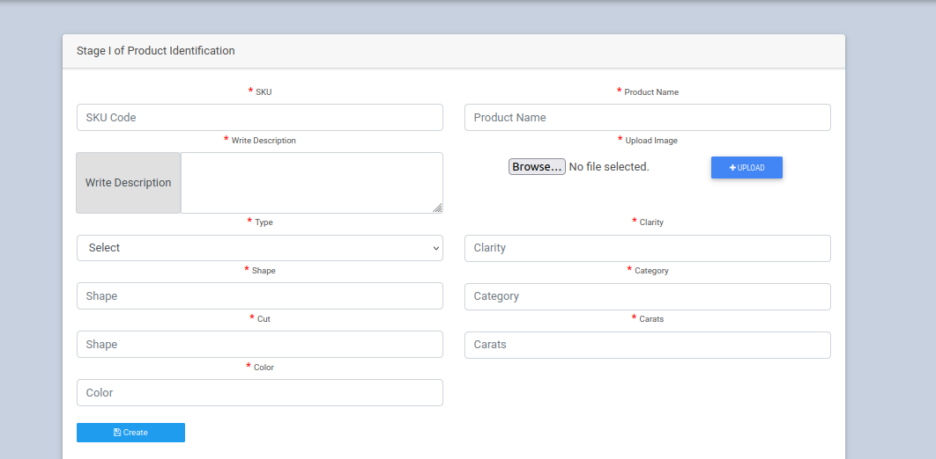

2.Product Details submitted to the blockchain.

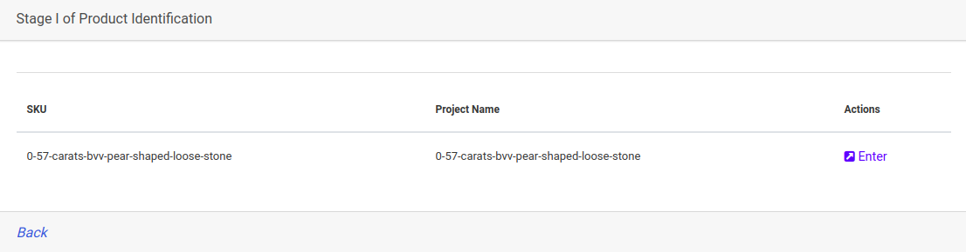

3.QR Code generated as a result of the data submitted to the blockchain.

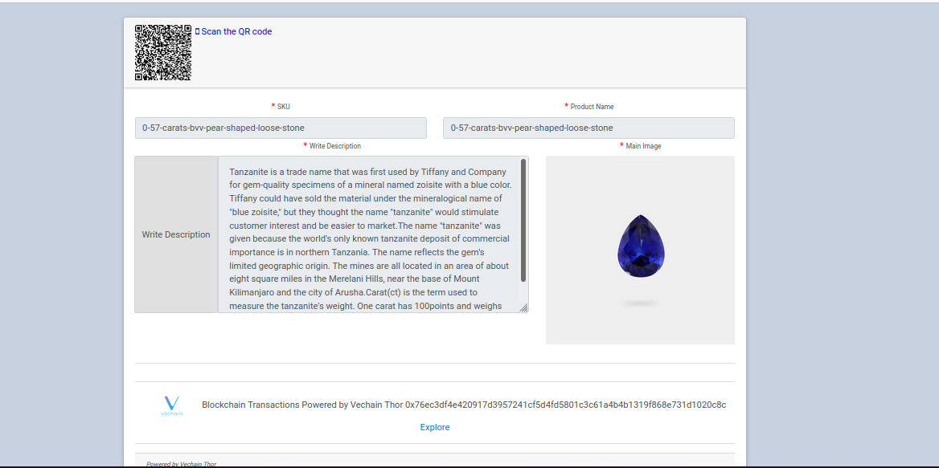

More Information that adds more traceability information to Tracechain that include PDF files such as certificates,images and Map.

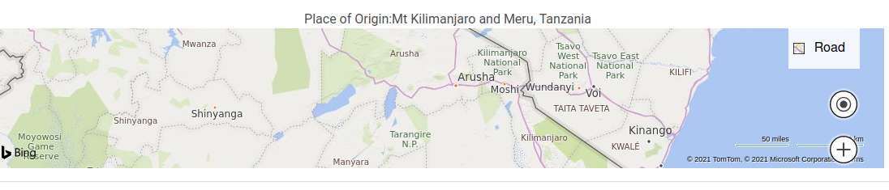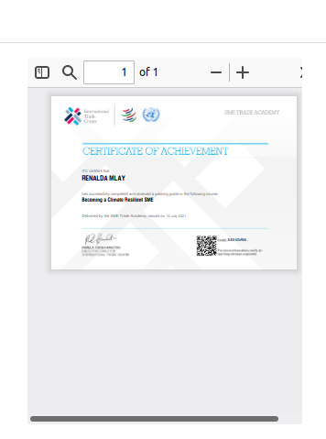 Map showing location and the place of origin of the product.

TXS generated by the Traceability Process showing the product is in the blockchain and is verified.

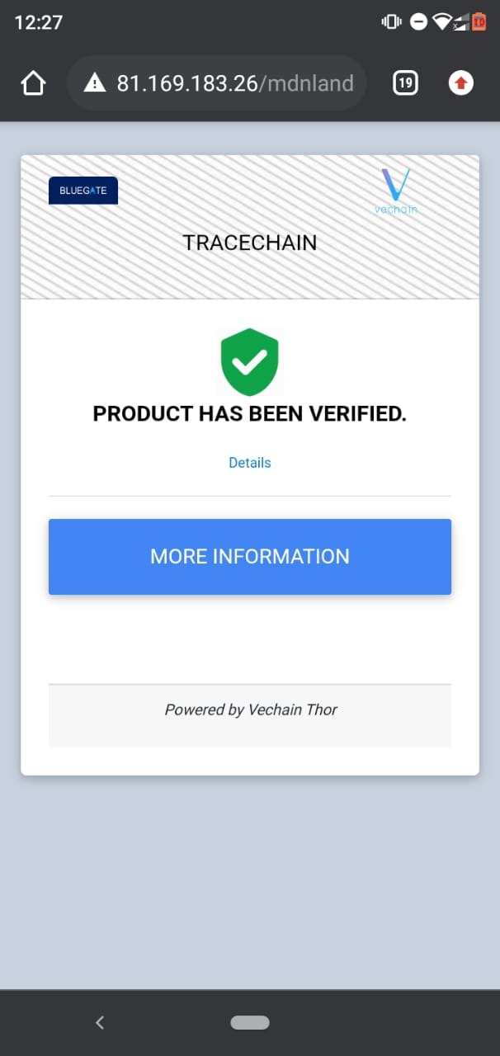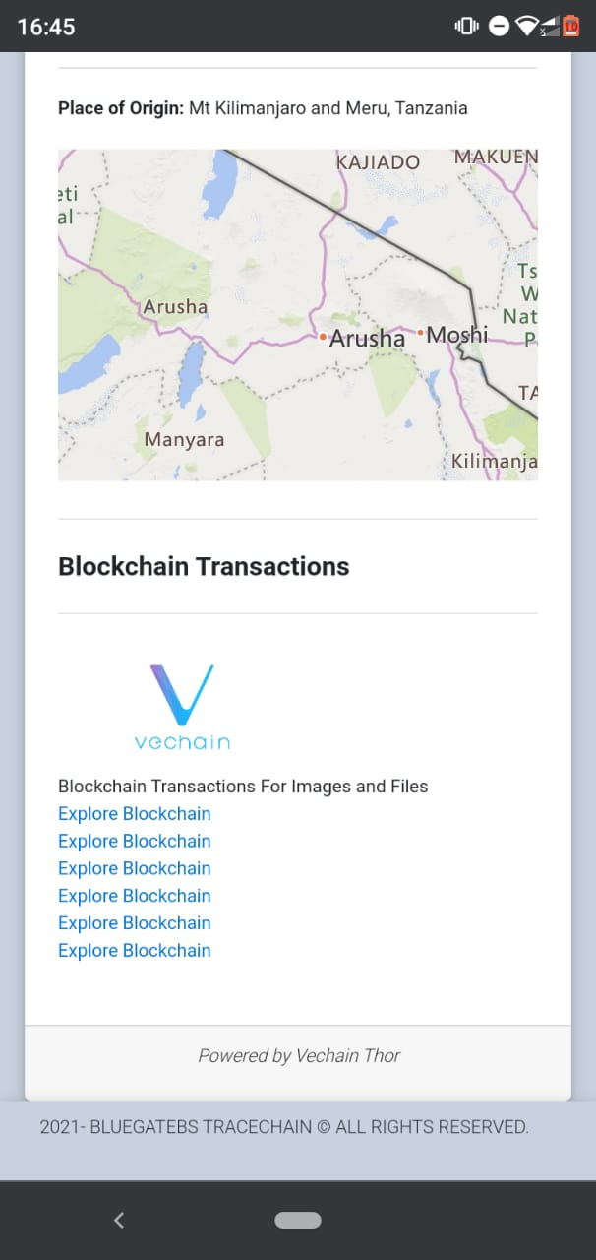

Validated data is added to the Tracechain and its hash is generated and uploaded to the VeChain Thor Blockchain. Qr code is generated immediately the data hash is sent to the VeChain blockchain .

**Steps to Upload and view traceability information.**  
•Fill in the required data fields in the form as shown in the screenshots.  
•Press on the create button to upload and hash the data to the blockchain.  
•Click on the enter action button to view the details of the whole process and to have a view of the QR code generated,for the QR There’s no need of a special APP or device to read your QR codes and verify your products. Any QR reader installed on your phone will detect and show the traceability information

**Madini MDN Token**  
MDN smart contract is build as VIP180 VeChain token. With full usability in Madini Ecosystem, anyone can earn, trade, transfer, pay, receive and invest in Madini MDN. MDN utility token main purpose is paying the services of traceability and is used for the purchases/selling of the minerals/metals.As every stakeholder of the marketplace will have a VeChain wallet, MDN will be used as Trading fee and also as payment option for the minerals.We have created a VeChain Thor – Madini Wallet (Android) to facilitate the Token management and allow the general public to invest, transfer and trade the MDN/VET/VTHO tokens.  
**MDN** – Main token MDN – Main value: adoption and utility (MDN is linked to all the Madini products, main CC for the Madini Wallet and the Madini Marketplace)

Initial Value 0,01 USD (Aprox 1 KSH)

Total supply: 100,000,000

MDN Decimal positions: 18  
Contract : <https://explore.vechain.org/accounts/0x1b44a9718e12031530604137f854160759677192>  
Madini Wallet Link:<https://www.madiniafricainvest.com/apk/MadiniWallet.apk>

**Madini VeChain Thor Wallet**  
Madini Wallet is a light mobile wallet app based on VeChainThor. We have forked VeChain github original code to buid Madini Wallet specific features and completely change the design and usability in Java. We aim to provide users with a powerful, secure, simple, fully functional portal of the Madini VeChainThor blockchain.  
Main functions include: MDN, VET, VTHO and other Crypto assets management, Balance, Exchange using Nomics API, Graph, Blockchain Inspector to check your transactions status, wallet observation, reward claim, etc.

**MDN Mainnet Contract (.sol)**

pragma solidity ^0.4.24;  
// ----------------------------------------------------------------------------  
//Madini Mainnet Token  
// Symbol : MDN   
// Name : Madini  
// Total supply: 100000000000000000000000000  
// Decimals : 18  
// ----------------------------------------------------------------------------  
// Safe maths  
// ----------------------------------------------------------------------------

……

// ------------------------------------------------------------------------  
// Owner can transfer out any accidentally sent ERC20 tokens  
// ------------------------------------------------------------------------  
function transferAnyERC20Token(address tokenAddress, uint tokens) public onlyOwner returns (bool success) {  
return TokenInterface(tokenAddress).transfer(owner, tokens);  
}  
}

***Powered by Vechain Thor***

